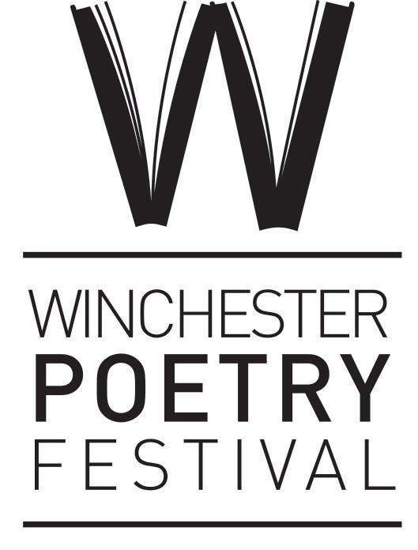
Winchester Poetry Prize 2026 - Entry Cover Sheet
Name:
Address:

Postcode:
Phone:
Email:

□ Please indicate if you would like to be added to our ongoing emailing list
Entry Titles:
1.
2.
3.
4.
5.
There is no limit to the number of poems you can enter. List additional titles overleaf.
❑ Please indicate if you are also paying for an entry in the ‘Pay it Forward’ scheme
How did you hear about the Winchester Poetry Prize?:

Return this form and two copies of your poem/s to: Winchester Poetry Prize, Winchester Poetry Festival, ℅ University Of Winchester, The Post Room, Sparkford Road, Winchester, SO22 4NR
If you would like acknowledgement that we have received your poems please include a SAE.

