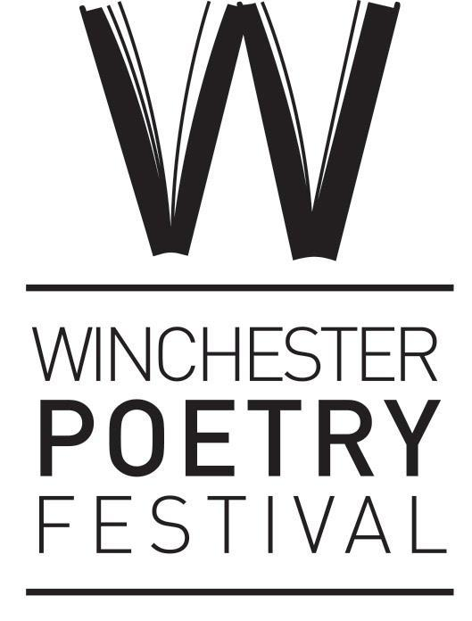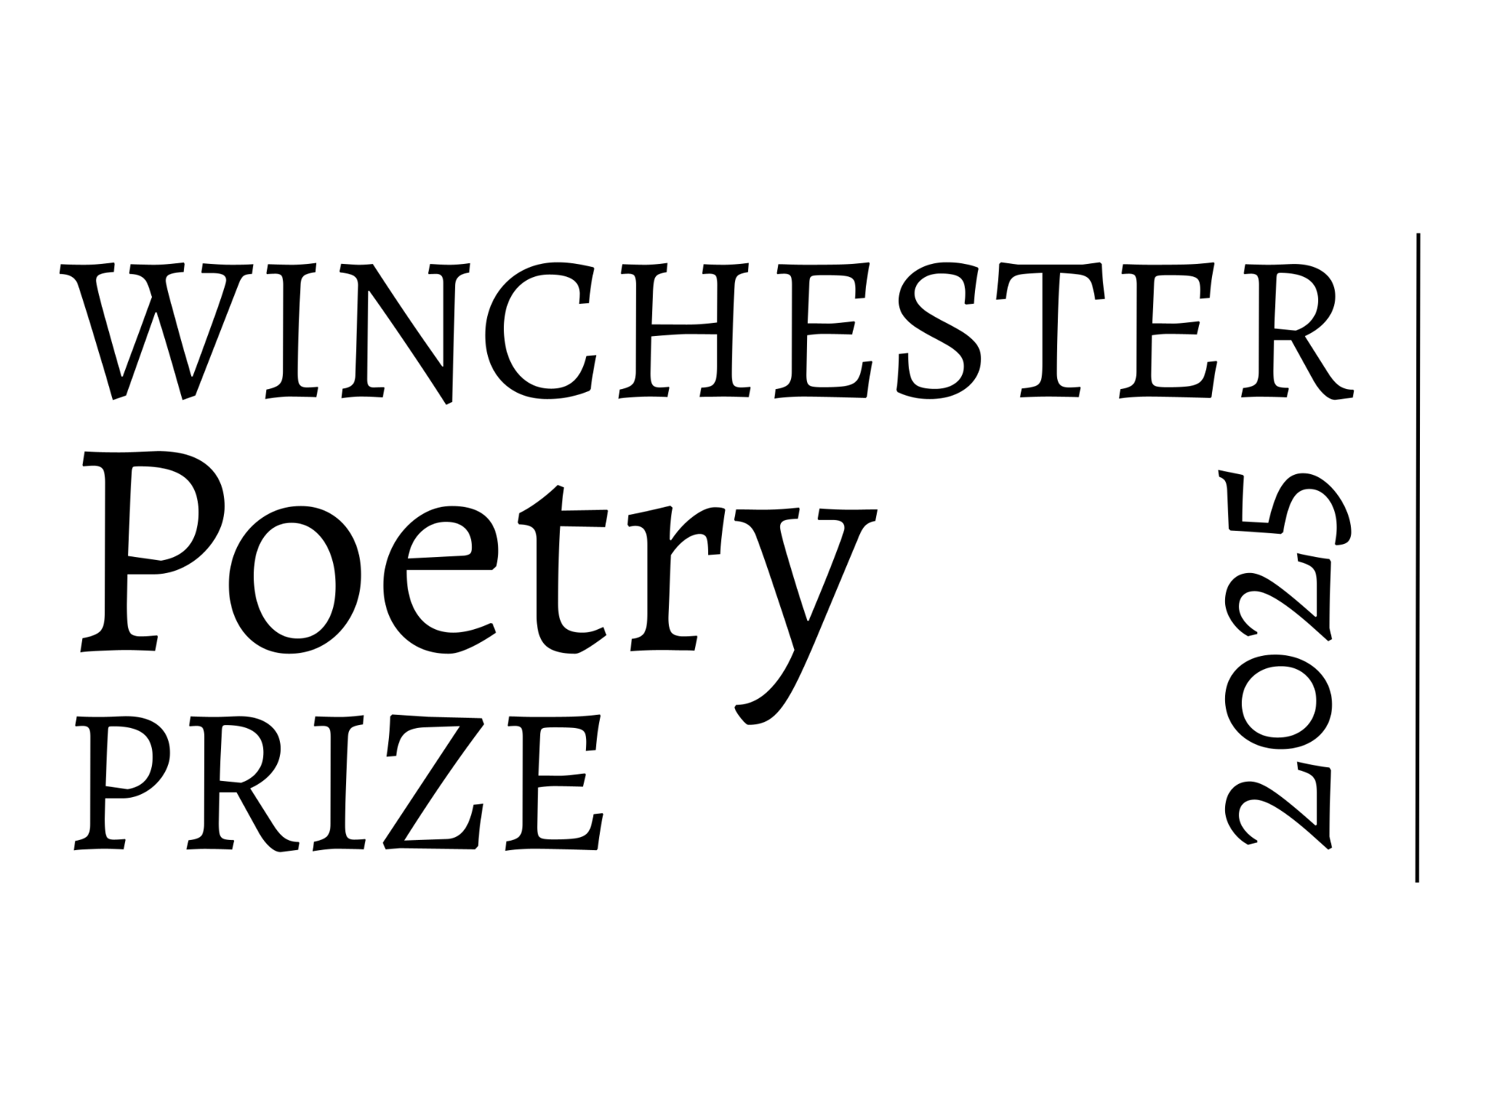
Winchester Poetry Prize 2025
Entry Cover Sheet – UoW Student entry
Name:
Course being studied:

Student Number:

Address:

Postcode:
Phone:
Email:
□ Please indicate if you would like to be added to our ongoing emailing list
Poem Titles:
1.
2.
3.
A maximum of 3 poems may be submitted for free by University of Winchester students.
Additional poems may be paid for (www.winchesterpoetryfestival.org/prize)

Return this form and two copies of your poem/s to:
Winchester Poetry Prize, Winchester Poetry Festival, ℅ University Of Winchester, The Post Room, Sparkford Road, Winchester, SO22 4NR
Or email completed form and poem to: entries@winchesterpoetryfestival.org

